# Installing the enviro:bit Library

Visit the MakeCode website. Select the cog in the top right-hand corner of the screen by left clicking on it. 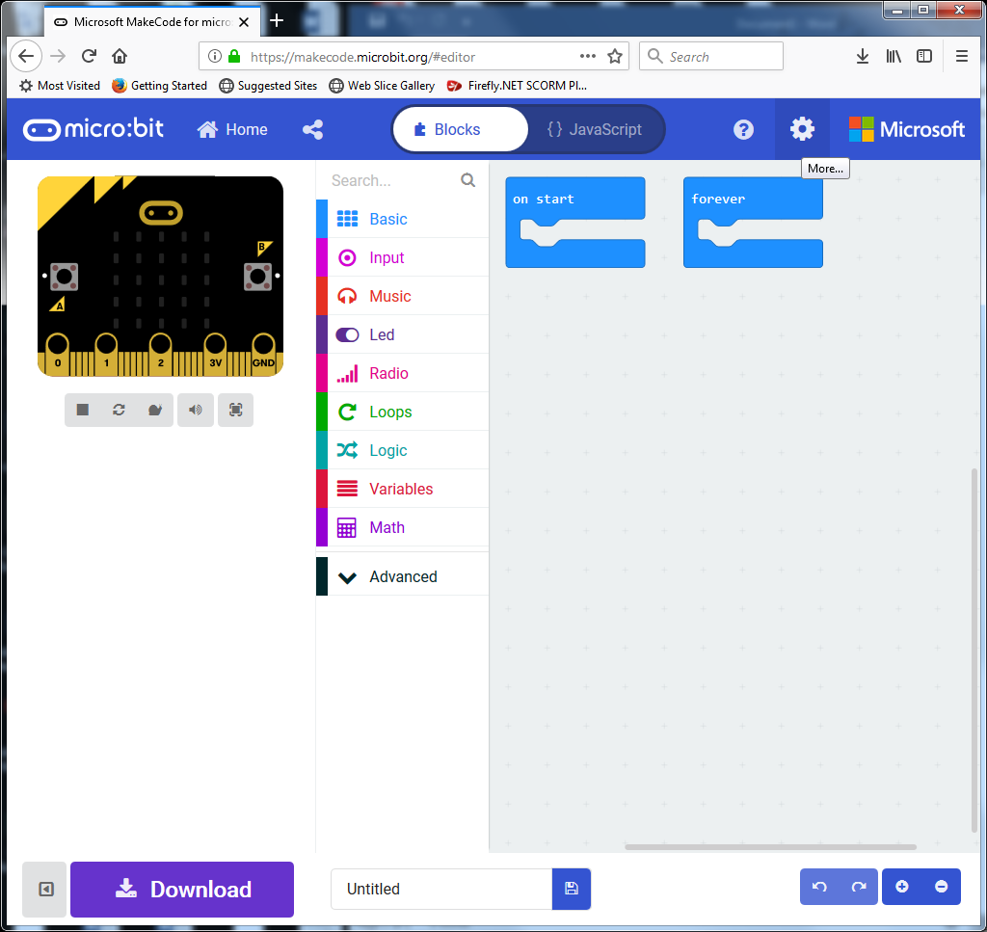

Once you have clicked on the cog you will see the menu below appear. You should then click on **Extensions**.

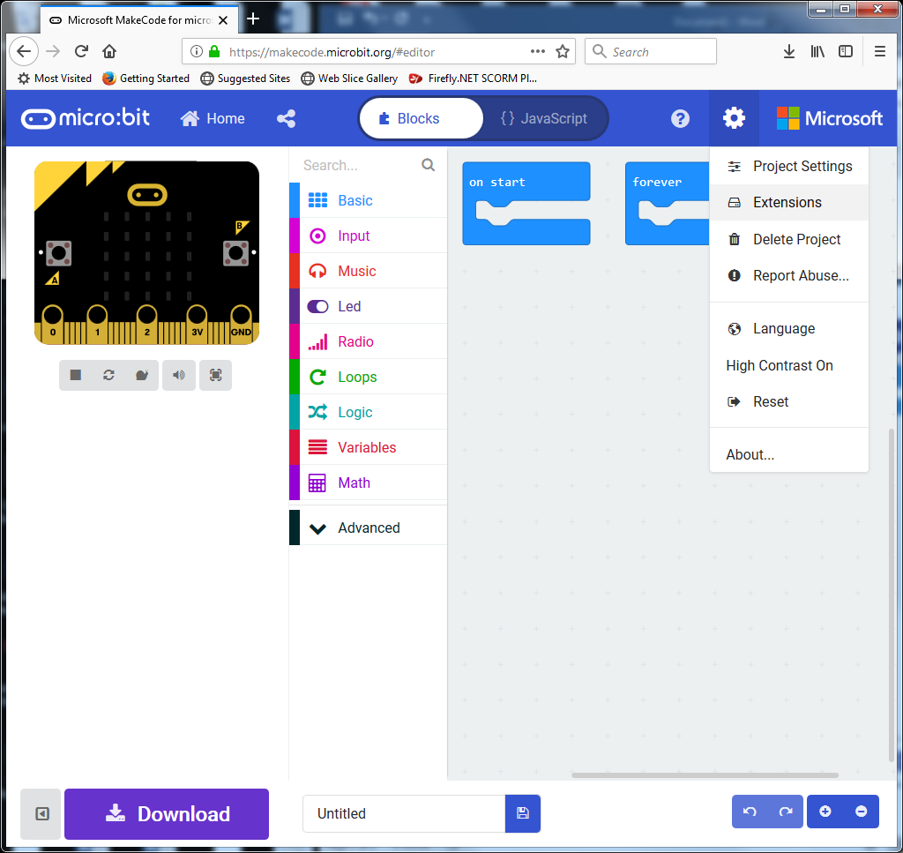

You will then see a range of extensions appear. The next step is to search for ‘enviro:bit’.

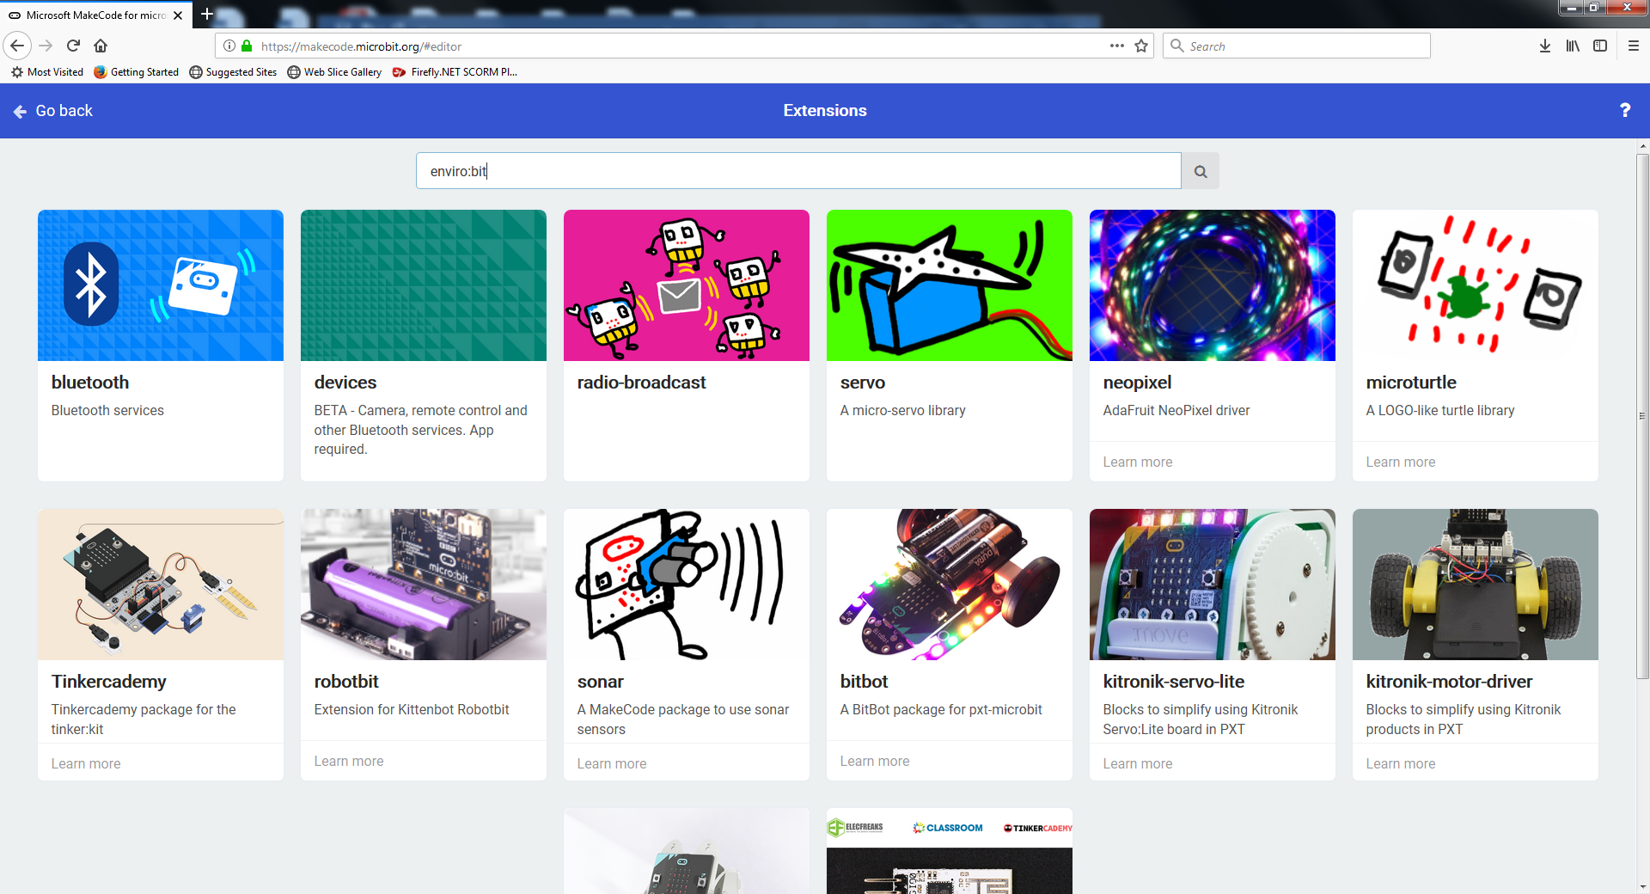

When you see an image of the enviro:bit, click on it to install the enviro:bit library.

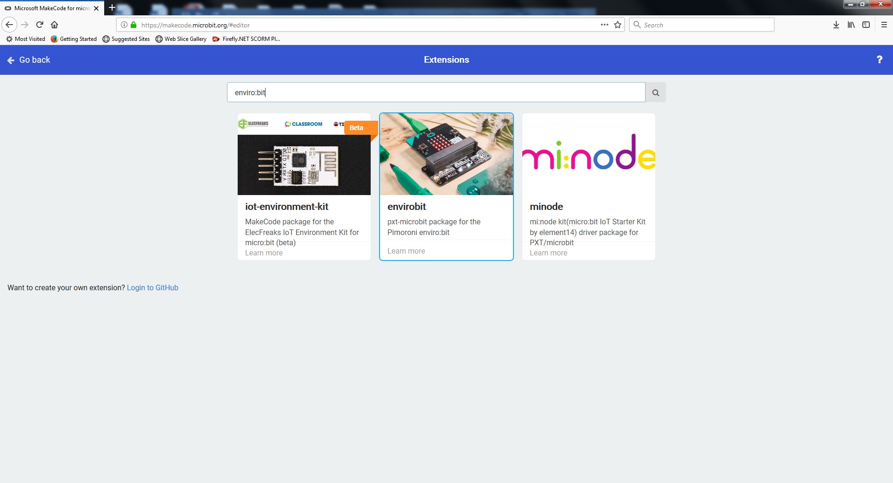

You will then see the **Enviro:Bit** code blocks appear on the MakeCode website.

